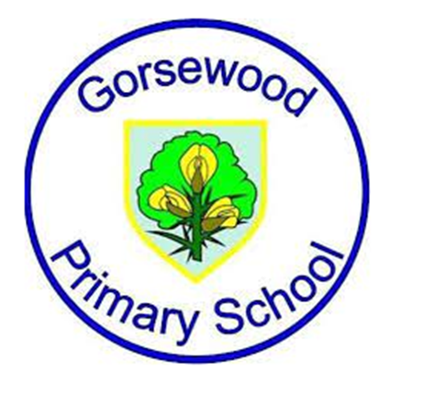

**GORSEWOOD PRIMARY SCHOOL**

**Long term overview - *2025-2026 Writing Roots Texts (Literacy Tree) - tbc throughout the year at salient times***

|  |  |  |  |  |  |  |
| --- | --- | --- | --- | --- | --- | --- |
| **Year group** | **Autumn 1** | **Autumn 2** | **Spring 1** | **Spring 2** | **Summer 1** | **Summer 2** |
| **Reception** | Whole School Book focus - ‘Change Sings’ by Amanda Gorman  Oi Frog by Kes Gray & Jim Field  And Tango makes Three by Justin Richardson & Peter Parnell | The Lights that Dance in the Night by Yuval Zommer | Whole School Book focus - ‘Flooded’ by Mariajo Illustrajo  Bringing the rain to Kapti Plain by Verma Aardema  Anansi the Spider by Gerald McDermott | ‘The Extraordinary Gardner’ by Sam Boughton (EE has)  The Tiny Seed by Eric Carle | Izzy Gizmo by Pip Jones    Izzy Gizmo and the Invention Convention by Pip Jones | ‘Super Millie’ by Stephanie Clarkson  The Magic Paintbrush by Julia Donaldson |
| **Year 1** | Whole School Book focus - ‘Change Sings’ by Amanda Gorman  Beegu by Alexis Deacon  The Comet by Joe Todd Stanton | Iggy Peck Architect by Andrea Beaty & David Roberts  Yeti and the Bird by Nadia Shireen | Whole School Book focus - ‘Flooded’ by Mariajo Illustrajo  Sidney, Stella and the moon by Emma Yarlett | Naughty Bus by Jan & Jerry Oke  Pig the Pug by Aaron Blabey | Leo and the Octopus by Isabelle Marinov  Stanley’s Stick by John Hegley | The Sea Saw by Tom Percival  Stella and the seagull by Georgina Stevens |
| **Year 2** | Whole School Book focus - ‘Change Sings’ by Amanda Gorman  Last stop, Market Street by Matt de la Pena  Me and You by Anthony Browne | Rosie Revere - Engineer by Andrea Beaty  The Owl and the pussycat by Edward Lear | Whole School Book focus - ‘Flooded’ by Mariajo Illustrajo    A walk in London by Salvatore Rubbino | Ocean meets the sky by Terry Fan & Eric Fan  The Journey Home by Frann Preston Gannon | ‘Dear Earth’ by Isabel Otter & Clara Anganuzzi | The Great Fire of London by Emma Adams |
| **Year 3** | Whole School Book focus - ‘Change Sings’ by Amanda Gorman  Small in the City by Sydney Smith | The First Drawing by Mordicai Gerstein | Whole School Book focus - ‘Flooded’ by Mariajo Illustrajo  Wilderness by Steve McCarthy | How to Live Forever by Colin Thompson | ‘Escape from Pompeii’ by Christina Balit | Cinderella of the Nile by Beverley Naidoo |
| **Year 4** | Whole School Book focus - ‘Change Sings’ by Amanda Gorman  The Iron Man by Ted Hughes | Until I met Dudley by Roger McGough | Whole School Book focus - ‘Flooded’ by Mariajo Illustrajo  The Ever-Changing Earth by Grahame Baker-Smith | Weslandia by Paul Fleischman | Riddle Runes by Janina Ramirez | The Lion the Witch and the Wardrobe by CS Lewis |
| **Year 5** | Whole School Book focus - ‘Change Sings’ by Amanda Gorman  The Lost Thing by Shaun Tan | The Rainplayer by David Wisniewski | Whole School Book focus - ‘Flooded’ by Mariajo Illustrajo  The Whale by Ethan & Vita Murrow | Freedom Bird by Jerdine Nolen  or  ‘The Tempest’ by William Shakespeare  or  ‘The Island’ by Armin Creder | ‘The Lizzie Belle Mysteries’ by J T Williams | Percy Jackson Hidden Figures by Rick Riordan |
| **Year 6** | Whole School Book focus - ‘Change Sings’ by Amanda Gorman  ‘The Arrival’ by Shaun Tan | Suffragette: ‘The Battle for Equality’ by David Roberts | Whole School Book focus - ‘Flooded’ by Mariajo Illustrajo  Can we Save the Tiger? By Martin Jenkins | Resist by Tom Palmer | Some Places more than Others by Renee Watson | Windrush Child by Benjamin Zephaniah |