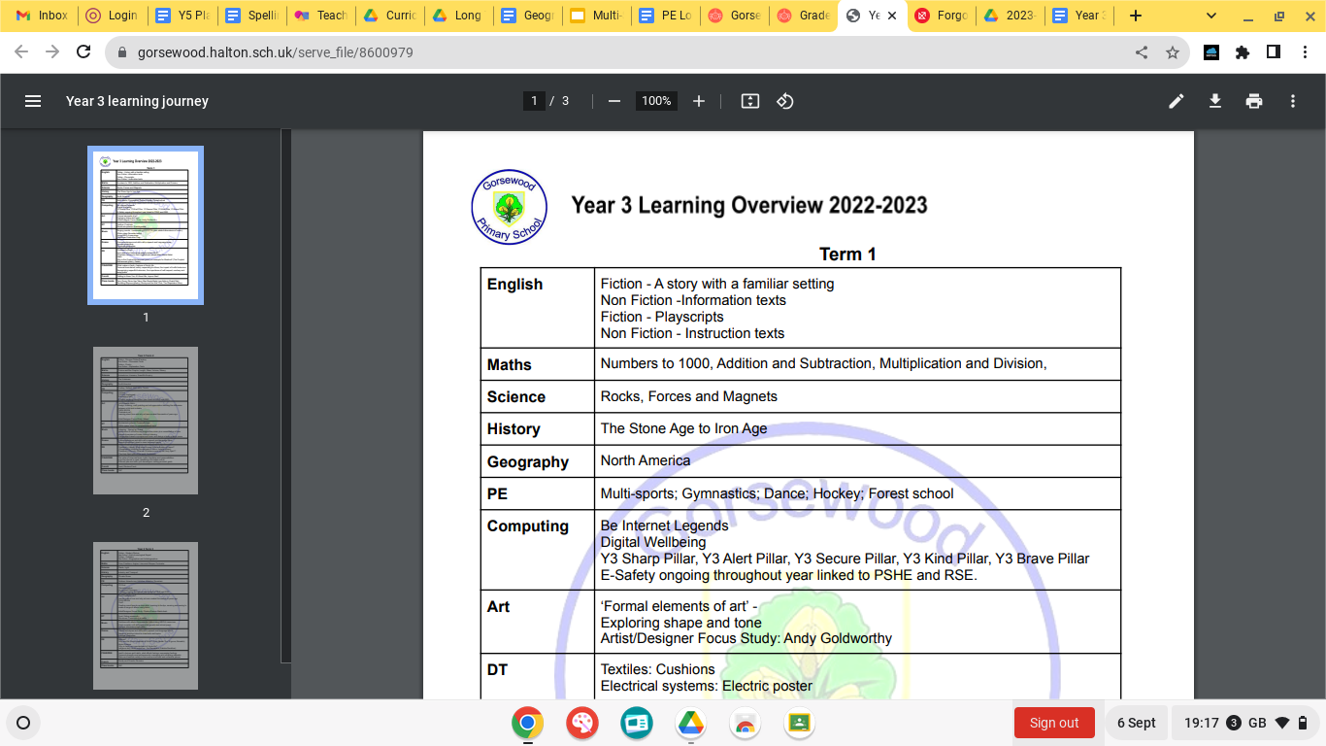

**Year 4 Learning Overview 2024-2025**

**Term 1**

|  |  |
| --- | --- |
| **English** | Whole School Book focus - ‘The Midnight Panther’ by Poonam Mistry  Tar Beach by Faith Ringgold  FArTHER by Grahame Baker Smith  Varmints by Helen Ward |
| **Maths** | Chapter 1- Numbers to 10 000  Chapter 2- Addition and subtraction  Chapter 3- Multiplication and division  Chapter 4- multiplication and division |
| **Science** | Electricity  Animals including Humans - Digestion, teeth, food chains |
| **History** | Roman Empire |
| **Geography** | Rivers - local area |
| **PE** | A logo with a flower and text  Description automatically generatedGymnastics Hockey Dance  Netball Forest School |
| **Computing** | E-safety ongoing Be Internet LegendsDigital Wellbeing Y4 Sharp Pillar Y4 Alert Pillar Be Internet Legends  Y4 Secure Pillar Y4 Kind Pillar Y4 Brave Pillar |
| Art | Drawing: Power prints Artist/Designer Focus Study: David Hockney |
| **D.T.** | Mechanical systems: Making a slingshot car |
| **Music** | Introduction to written notation for rhythm.  Christmas Production Prep. Singing in 2 part harmonies - incorporating DR PITTS (inter related dimensions of music) |
| **Drama** | Drama techniques and skills with a speech and language focus;  Harvest production;  Christmas production |
| **RE** | Hindu Dharma  ***What might a Hindu learn through celebrating Diwali?***  Vishnu.  Rama and Sita.  Diwali. Islam  ***Why do Muslims fast during Ramadan?***  The Five Pillars of  Islam,  Ramadan. |
| **PSHE/RSE** | Introductory lesson  Family and relationships Health and wellbeing |
| **French** | A logo with a flower and text  Description automatically generatedAll Around Town Christmas |

**Term 2**

|  |  |
| --- | --- |
| **English** | The Iron Man by Ted Hughes  ‘Winters Child’ by Angela McAllister  ‘Cinnamon’ by Neil Gaimin  ‘Frindleswylde’ by Natalia & Lauren O’Hara |
| **Maths** | A logo with a flower and text  Description automatically generatedChapter 5 - Graphs  Chapter 6 - Fractions  Chapter 7 - Time Chapter 8 - Decimals |
| **Science** | Living Things and Their Habitats - Conservation  States of Matter |
| **History** | Vikings/Anglo Saxons and Scots |
| **Geography** | Rainforests |
| **PE** | Hockey Swimming Multi-skills Tag Rugby |
| **Computing** | CS First: Music and Sound  CS First: Code your Hero |
| **Art** | Painting and mixed media: Light and dark  Craft and design: Fabric of nature Artist/Designer Focus Study: Karla Gerard |
| **D.T.** | Cooking and Nutrition: Adapting a Recipe |
| **Music** | Listening - ‘Vltava’ by Smetana.  Programme music and romantic era.  Begin composition work based on this theme. Continue composition work for programme music.and design a detailed graphic score. |
| **Drama** | Drama techniques and skills with a speech and language focus;  Range of activities linked to class texts and topics |
| **RE** | Christianity (Church): ***HIs sacrifice an important part of religious life?*** (jesus in the wilderness, Lent) Christianity (Jesus):  ***How and why might Christians use the Bible?***  (Christian life) |
| **PSHE/RSE** | Health and wellbeing  Safety and the changing body |
| **French** | Gone Shopping |

**Term 3**

|  |  |
| --- | --- |
| **English** | The Ever Changing Earth by Grahame Baker-Smith  Shackletons Journey by William Grill  The Lion the Witch and the Wardrobe by CS Lewis  Jabberwocky by Lewis Carroll |
| **Maths** | A logo with a flower and text  Description automatically generatedChapter 9 - Money  Chapter 10 - Length, Mass & Volume  Chapter 11 - Area and Perimeter of Figures  Chapter 12 - Geometry  Chapter 13 - Position and Movement  Chapter 14 - Roman Numerals |
| **Science** | Living Things and Their Habitats (classifying) Sound |
| **History** | Crime and Punishment |
| **Geography** | South America - the Amazon |
| **PE** | Tennis  Outdoor Adventurous Activities Athletics  Rounders |
| **Computing** | CS First: Interactive Presentation  CS First: CS First Unplugged |
| **Art** | Craft and design: Fabric of nature  Sculpture and 3D: Mega materials Artist/Designer Focus Study: Wassily Kandinsky |
| **D.T.** | Textiles: Fastenings |
| **Music** | Begin pitch notation both reading from and writing.  Performance of piece from notation on glockenspiels.  Preparation for performance of ‘drumstick project’  Summer showcase preparation. |
| **Drama** | Drama techniques and skills with a speech and language focus;  Range of activities linked to class texts and topics;  Summer Production |
| **RE** | Sikhism  ***How do Sikhs express their beliefs and Values?*** the 5 Ks,  Equality,  the Gurdwara **Christianity:** **What does love your neighbour really mean?**  (Church, parables, love for all) |
| **PSHE/RSE** | Citizenship  Economic Well Being  Transition lesson |
| **French** | Where in the World? Revision of previous learning. Using language |

