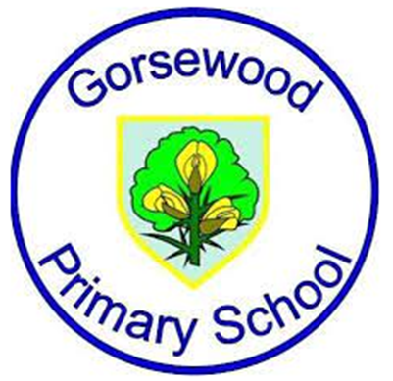
GORSEWOOD PRIMARY SCHOOL
Long term overview - FRENCH

Year group | Autumn 1 | Autumn 2 | Spring 1 | Spring 2 | Summer 1 | Summer 2
Year 2 |  |  |  |  |  | Greetings  Numbers to 10
Year 3 | Getting to Know You | Remembrance Day, + Christmas | All About Me | All About Me cont. | Food Glorious Food | Family and Friends
Year 4 | All Around Town | Remembrance Day + Christmas | Holidays and Hobbies | Holidays and Hobbies cont. | Gone Shopping | Where in the World?
Year 5 | Getting to Know You | Remembrance Day + Christmas | All About Me | All About Me cont. | That’s Tasty | Family and Friends
Year 6 | This is France | Remembrance Day + Christmas | All in a Day | All in a Day cont. | Let’s Go Shopping | Let’s Visit a French Town

